圆来缘去
Cycles of Destiny
为华乐团而作
for Chinese Orchestra

莫健儿
Raymond Mok Kin Yee

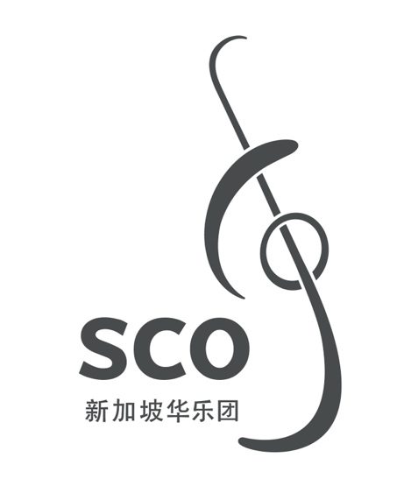

00/000
圆来缘去
Cycles of Destiny
为华乐团而作
for Chinese Orchestra

莫健儿
Raymond Mok Kin Yee

(2011, rev. 2023)

10’30”

圆来缘去
Cycle of Destiny

ISMN

Copyright © Singapore Chinese Orchestra Co. Ltd. All rights reserved.

版权所有, 未经许可, 不得以任何形式印刷、复制、扫描或发行。
Unauthorised printing, reproduction, scanning or distribution is strictly prohibited
without the express permission of the copyright holder.

印刷于新加坡。
Printed in Singapore.

新加坡华乐团有限公司
珊顿道7号
新加坡大会堂
新加坡邮区 068810

Singapore Chinese Orchestra Co. Ltd.
7 Shenton Way
Singapore Conference Hall
Singapore 068810

网站Website: www.sco.com.sg
电邮Email: aa@sco.com.sg
电话Telephone: (65) 6557 4026
传真Fax: (65) 6557 2756

传Biography
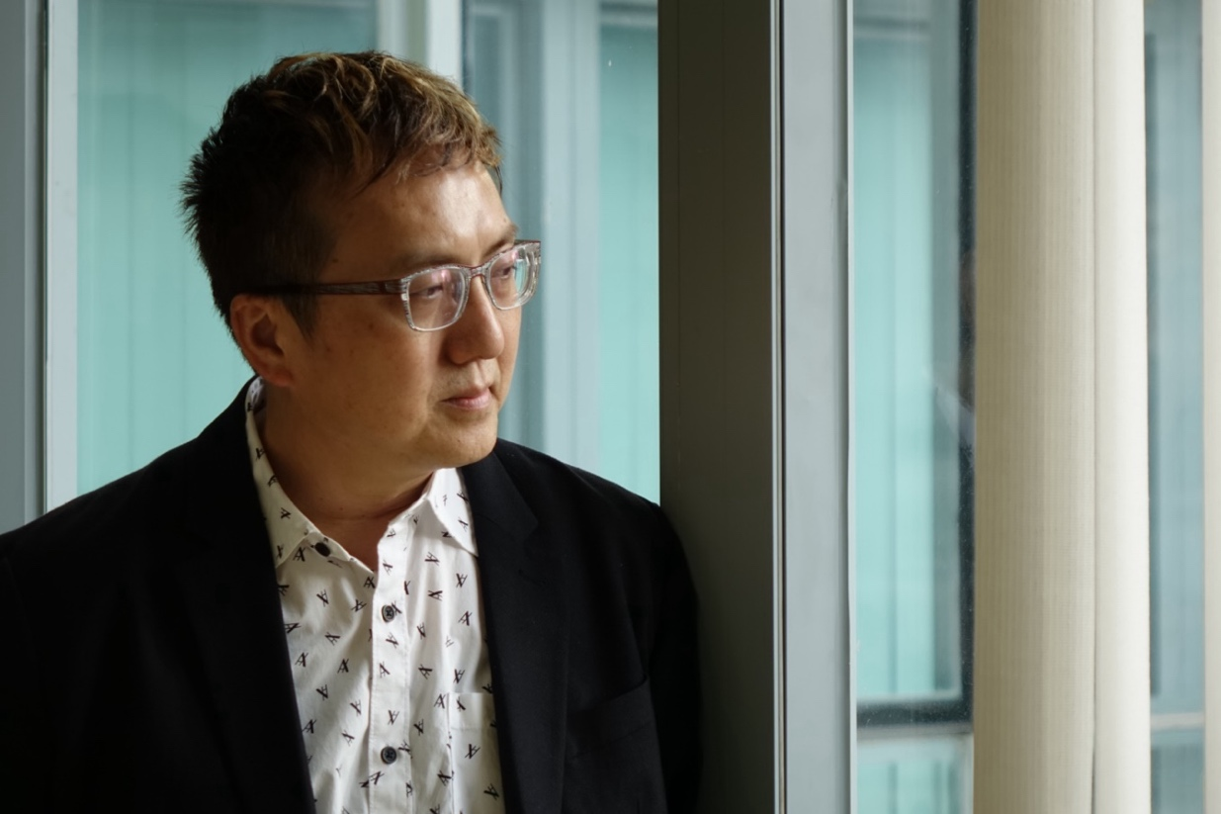
持有倫敦聖三一音樂學院作曲院士文憑、香港大學作曲哲學碩士及澳洲阿德萊德大學作曲哲學博士。學習期間重要的老師分別是葉純之教授、葉小鋼教授、陳慶恩博士、格美. 高尼博士及金美. 哥積克博士。
其作品曾在香港中樂團心樂集、香港中樂團香江華采、香港音樂新文化、北京現代音樂節、國際現代音樂協會世界音樂日、聯合國教科文組織之國際作曲家論壇、中國交響樂世紀回顧暨第二屆中國交響音樂季－河北展演周、新加坡國際華樂作曲大賽得獎作品音樂會及亞洲作曲家聯盟大會暨亞太音樂節、臺灣小巨人絲竹樂團室內樂系列、中國之聲第二屆作曲比賽獲獎作品音樂會、俄羅斯索契音樂節、澳門純音雅詠合唱團週年音樂會及澳門藝術節等中發表。
莫氏在2002年后移居澳門，現為澳門理工大學音樂課程副教授。 在2011年，其作品《圓來緣去》在新加坡國際華樂作曲大賽中榮獲南洋獎、2013年，笛子獨奏《惑》在“中國之聲”（第一屆）作曲比賽中獲得民樂獨奏作曲家組ニ等獎、2014年，《清歌一闕》在“中國之聲”（第二屆）作曲比賽中獲得中西管弦樂器混合作曲家組一等獎。

Raymond Mok obtained the FTCL in Music Composition from the Trinity College, a Master of Philosophy in Music Composition from the University of Hong Kong and Doctor of Philosophy in Music Composition from the University of Adelaide. A number of teachers were influential to his studies, including Prof. Ip Shun-chi, Prof. Ye Xiao-gang, Dr. Chan Hing-yan, Dr. Graeme Koehne and Dr. Kimi Coaldrake.
As a composer, Mok’s compositions had been widely performed in concerts such as Music to Touch Your Heart, HK Musicarama, Beijing Modern Music Festival, ISCM-ACL, World Music Day, Hong Kong Cadenza, Composers League Conference and Festival, Russia Sochi Arts Festival, Macau Dolce Voce Annual Concert, Macau Arts Festival and so on.
Raymond migrated to Macau in 2002 and is currently Associate Professor in the Music School of The Macau Polytechnic University. In 2011, his composition “Cycles of Destiny” gained the Nanyang Award from Singapore International Competition for Chinese Orchestral Composition, in 2013, “Bewilderment” for Chinese flute solo gained the 2nd prize from the “Voice of China Composition Competition” (Beijing), in 2014, “A Petit Song for sheng, erhu, Piano and Percussion” gained the 1st prize from the “Voice of China Composition Competition” (Beijing).

乐曲介绍Synopsis
此曲為香港中樂團委約作品，為介紹香港圓玄學院而創作。圓玄學院是香港的宗教聖地，寺院的思想內容廣博且形式多樣，兼容儒、道、佛三教。寺院包羅萬象的研修內容使我在創作此樂曲時能自如地選擇古今中外的音樂素材，跳脫一種宗教的思維定式，透過拼貼和並置的手法，把各種素材加以提煉和發展。
在樂曲中，由三組管樂環環相扣通過迴環方式演奏而成的“圓”是其中的重要音樂素材，“圓”內部音樂素材的融合以及與外圍音樂素材的碰撞最能彰顯到樂曲在色彩上的混合與對比；而在樂曲的最後，不同的音樂素材在完成了自身的起承轉合之後結束演奏，樂曲的素材慢慢遞減，直到最後一種素材慢慢消逝——緣起緣去。

The composition depicts The Yuen Yuen Institute which is a place of learning Taoism and religious retreat. But it is distinguished by an integrative, all-embracing intellectualism, with its pantheistic approach to religion, including Confucianism. Its non-exclusive stance has become an inspiring perspective for me in composing this work. I felt I was uninhibited by subject matter, style and cultural background and was free to choose whatever I wanted in the treasury of music of East and West, to remix and juxtapose them for a collage that sublimates and develops into something new.
Name of the composition inspires from the middle section of the piece, three non-conducted “Circle Music” are comprised of wind instruments and are requested to provide a sense of endlessness through their progression. As a result, when these three circles are juxtaposed with the conducted music which is formed by bowed strings, a contrasting, crashing as well as chaotic sonic effect with huge tessitura is created. The music enters a climatic section, then ends in a quiet, contemplative manner.

编制Instrumentation
1 梆笛 1 Bangdi
1 曲笛 1 Qudi
1 新笛 1 Xindi
1 笙 1 Sheng
2 高音唢呐 2 Gaoyin Suona
1 中音唢呐 1 Zhongyin Suona

1 扬琴 1 Yangqin
1 琵琶 1 Pipa
1 中阮 1 Zhongruan
1 大阮 1 Daruan

5 打击乐 5 Percussion:
I: 中国大鼓 Zhongguo Dagu
II: 排鼓Paigu , 小钟琴 Glockenspiel, 大锣 Daluo
III: 大锣 Daluo, 梆子 Bangzi, 颤音琴 Vibraphone
IV: 铃鼓 Tambourine, 吊镲 Suspended Cymbals
V: 小镲 Xiaocha, 三角铁 Triangle, 大钹 Dabo

高胡 Gaohu
二胡 Erhu
中胡 Zhonghu
大提琴 Violoncello
低音提琴 Contrabass

